- Introduction

  - Ubiquitous Computing

Ubiquitous computing it is also known as (“ Ubicomp”) is a concept is software engineering and computer science where computing is made to appear anytime and anywhere. In contrast to desktop computing, ubiquitous computing can occur using any device, in any location, and in any format.

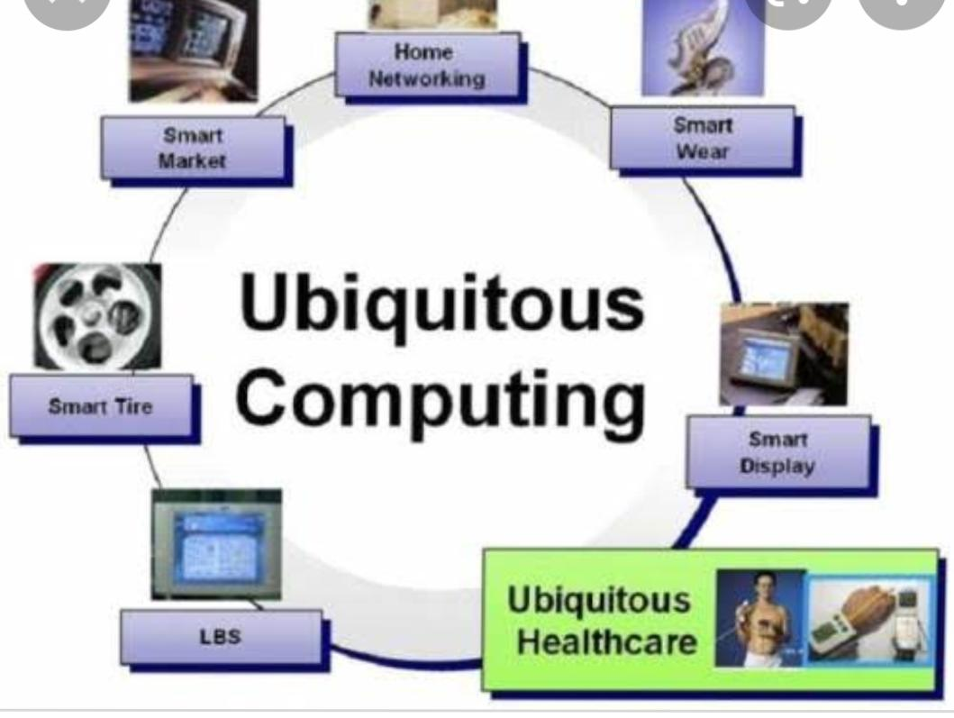

Figure 1: Ubiquitous computing.

  - Examples of ubiquitous computing.

Services like apples iCloud, which allows users to seamlessly access their data from a range of devices no matter where they are, obvious parts of the ubiquitous computing paradigm. Like as….
1.2.1 Laptops
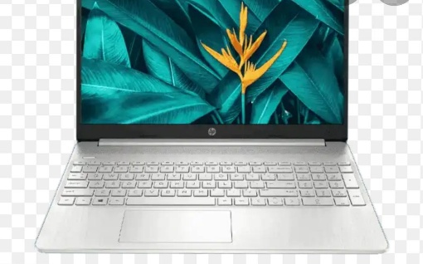
A small computer that is easy to carry and that can use batteries for power.
Figure 2 : Laptops

    - Notebooks

A small book in which you right things that you want to remember.

Figure 3 : Notebooks

    - Smartphones
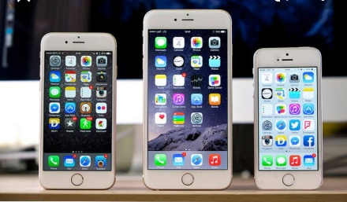
A cell phone that has function like that of a computer.
Figure 4 : Smart phone’s

    - Tablets
Tablet is a wireless, portable personal computer with a touchscreen interface.
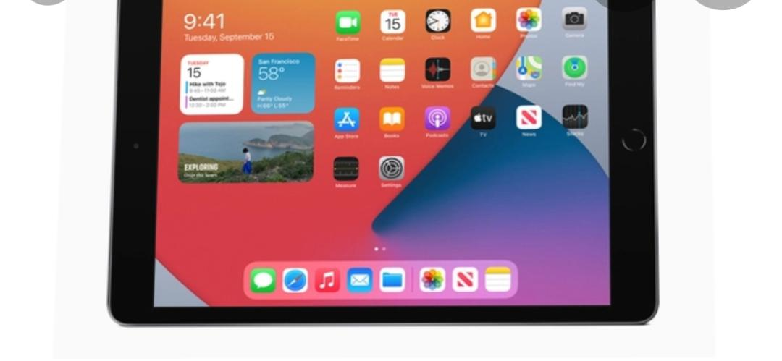
Figure 5 : Tablets

    - Wearables
It is a category of electronic device that can be worn as accessories, embedded is clothes.

- What does meant by ubiquitous computing

Ubiquitous computing is a paradigm in which the processing of information is linked with each activity or object as encountered. It involves connect a electronic device, including embedded microprocessor to communicate information. Devices that use ubiquitous computing have an availability and are completely connected.
Ubiquitous computing focus on learning by removing the complexity of computing and increase efficiency while using computing for different daily activities.
The main focus of ubiquitous computing is the creation of smart products that are connected, making communication and the exchange of data eraser and less obtrusive.
Key features of ubiquitous computing include:
- Consideration of the human factor and placing of the paradigm in a human, Rather then computing, environment.
- Use of inexpensive processors, thereby reducing memory and storage requirements.
- Capturing of real time attributes.
- Totally connected and constantly available computing devices.
- Focus on memory to memory relationship, institute of one to one, many to one or one to many in the environment, along with the idea of technology, which is constantly present.
- Includes local/global, social/personal, public/private and invisible/visible features and considered knowledge creation, as well as information dissemination.
- Relies on converging internet, wireless technology and advanced electronics.
- Increase surveillance and possible restriction and interference in user privacies, as the digital device are wearable and constantly connected.
- As technology progresses, the reliability factor of the different equipment used may be impacted.

  - The aim of ubiquitous computing
Ubiquitous computing aims to permeate and interconnect all areas of life, and to enable our ubiquitous follow of data information, and pi integrating cognitive capabilities in the future even knowledge.

  - The advantages of ubiquitous computing
In the long term, ubiquitous computing can pervade all Spears of life: it promises to increase comfort in the private home area and to improve energy efficiency, intelligent vehicles may make roads safer, adopted personal assistant systems could work productivity in the office, and in the medical field.

- IoT in ubiquitous computing

Ubiquitous computing is a term associated with the internet of things (IoT) and refers to the potential of connected device and their benefits to become commonplace.
It is also called ambient computing or pervasive computing, ubiquitous computing can be described as the saturation off work, living, and transportation spaces with devices that inter communicate. These embedded systems would make the settings and transportation methods considerably more enjoyable and convenient since through contextual data aggregation and application, seamless, intuitive access points, n fluid payment system.

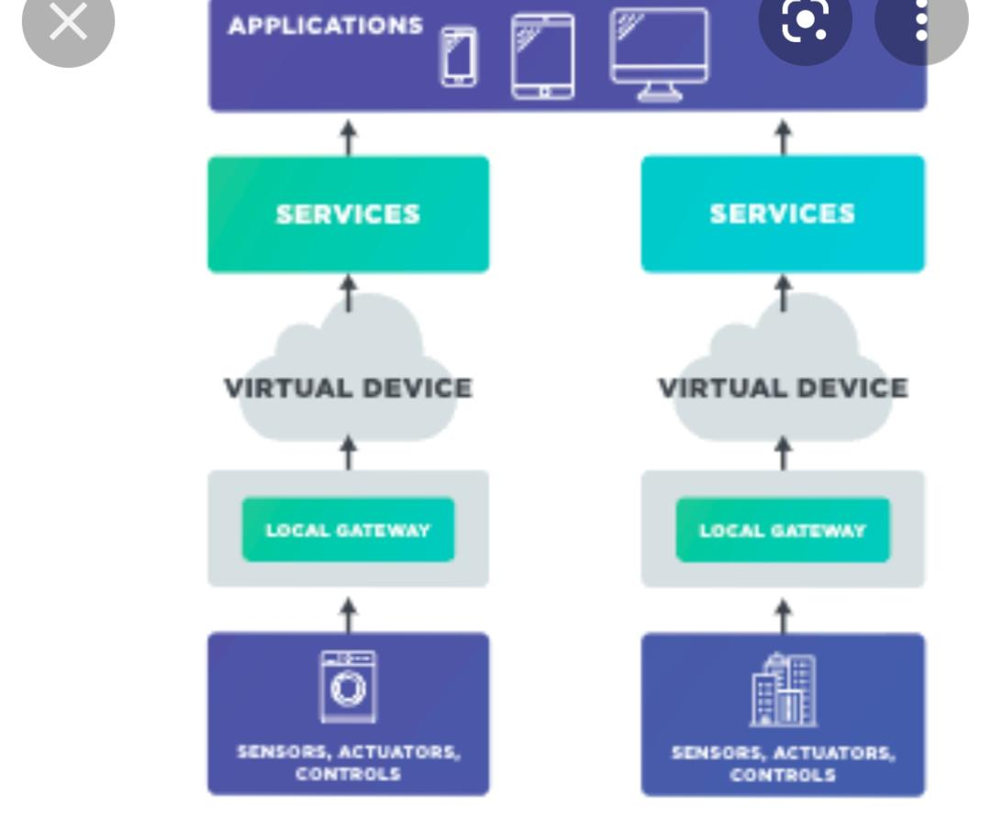
Figure 6: IoT ubiquitous computing.

- Ubiquitous computing: Applications and research opportunities

Computers and internet application exist everywhere and play an emerging role in our daily life. It is remarkable that the number of internet connected devices have exceeded the whole world population in the last few years. Collected data are analysed and processed for monitoring and control purpose as well as many other application in various fields. However, such omnipresence of technology has several technical, juridical, ethical, and environmental challenge that must be faced and resolve.
  - progress of related technologies
The proliferation of smartphones and tablet PCs has fostered an ample adoption of the mobile computing. In addition, the use of devices to location determination, search as the GPS, has pain stimulated bi as increase of precision combined with a decreasing of prices.

  - Applications
The significant impact generated by the adoption of internet has shown how an emergent technology can transform the practices in different application area. For example, the distance education (so called e learning) has revolutionized the educational strategies, changing the prospective form face to face approach to the remote learning. Another example is the commerce, where The E-Commerce has create a new paradigm to negotiate and stimulated the emergency of several companies decided to this market opportunity.

  - Accessibility
The term ubiquitous accessibility watch used to Gregg Vanderheiden to indicate a new technology approach to support accessibility. He argues that is the computing is shifting from personal workstation to ubiquitous computing, accessibility should be through accordingly with this new computational paradigm. In this sense, the u- accessibility has emerged as a way to improve the quality of life of people with disability and the elderly.

- Summary and Future Work

- Ubiquitous computing suggest countless very small, wirelessly inter complicating microprocessor, which can be more or less visibility embedded into object…. This ubiquity is reflected in a large number of almost identical concepts, such as ”pervasive computing”, “ambient intelligent” and “ the internet of things.”

- In contract to desktop computing, ubiquitous computing can occur using any device, in any location and in any format. A user interact with the computer, which can exist if many different forms, including laptop computer, tablets and terminals in everyday objects such as a refrigerator for a pairs of glasses.

References

- Jing, L., Ming, L., Bin, Y., Wenlong, L., A Novel Energy Efficient MAC Protocol for Wireless Body Area Network. China communication, Feb. 2015.
- Negra, R., Jemili, I., Belghith, A.: Wireless Body Area Networks: Applications and Technologies. Procedia Computer Science 83, 1274 – 1281 ( 2016 )
- Yuce, M.R.: Implementation of wireless body area networks for healthcare systems. In: Sensors and Actuators A: Physical, Vol 162, Issue 1, Pages 116-129. Elsevier B.V (2010)
- Dabhi, K., Mahet, A.: Internet of Nano Things-The Next Big Thing. In: International Journal of Engineering Science and Computing, vol 7 Issue No.4 (2017)
- Negra, R., Jemili, I., Belghith, A.: Wireless Body Area Networks: Applications and Technologies. Procedia Computer Science 83, 1274 – 1281 ( 2016 )
- Yuan, X., Li, C., Ye, Q., Zhan, K., Cheng, N., Zhan, N., Shen, X.: Performance Analysis of IEEE 802.15.6-Based Coexisting Mobile WBANs with Prioritized Trafﬁc and Dynamic Interference. In: IEEE Transactions on Wireless Communications (Volume: 17, Issue: 8, Aug. 2018)
- Adhikary S., Chattopadhyay S., Choudhury S.: A Novel Bio-inspired Algorithm for Increasing Throughput in Wireless Body Area Network (WBAN) by Mitigating Inter-WBAN Interference. In: Chaki R., Cortesi A., Saeed K., Chaki N. (eds) Advanced Computing and Systems for Security. Advances in Intelligent Systems and Computing, vol 667. Springer, Singapore (2018)
- Peng, H., Tian, Y., Kurths, J., Li, L., Yang, Y., Wang, D.: Secure and energy-efﬁcient data transmission system based on chaotic compressive sensing in body-to-body networks. IEEE Trans. Biomed. Circ. Syst. 11(3), 558–573 (2017)
- Samanta, A., Misra, S.: Energy-efﬁcient and distributed network management cost minimization in opportunistic wireless body area networks. IEEE Trans. Mobile Comput. 17, 376–389 (2017)
- Ahmad, S.S., Razzaque, M.A., Inmaculada T.R., Hussain, N.: IEEE 802.15.6 Standard in Wireless Body Area Networks From a Healthcare Point of View. The 22nd Asia-Pacific Conference on Communications (APCC2016)
- Yi, C., Wang, L., Li, Y.: Energy efﬁcient transmission approach for WBAN based on threshold distance. IEEE Sensors J. 15(9), 5133–5141 (2015)
- Misra, S., Moulik, S., Chao, H.-C.: A cooperative bargaining solution for priority-based data-rate tuning in a wireless body area network. IEEE Trans. Wirel. Commun. 14(5), 2769–2777 (2015)
- Walsh, M.J., Hayes, M.J.: Throughput rate control for an 802.15.4 wireless body area network using static and low order anti-windup techniques. In: Proc. Mediterranean Conf. Control Autom, pp.1–6 (2007)
- Eberhart, R., Kennedy, J.: A New Optimizer Using Particle Swarm Theory. Sixth International Symposium on Micro Machine and Human Science, 0-7803-2676-8/95
- Kalaiselvi, K., Suresh, G.R. & Ravi, V.: Genetic algorithm based sensor node classiﬁcations in wireless body area networks (WBAN). Cluster Comput (2018)
- Nadeem, Q., Javaid, N., Mohammad, S.N., Khan, M.Y., Gull, M.: SIMPLE: Stable Increased-throughput Multi-hop Protocol for Link Efﬁciency in Wireless Body Area Networks. 26, Jul. 2013.

